

**HO CHI MINH UNIVERSITY OF TECHNOLOGY AND EDUCATION**

**FACULTY FOR HIGH QUALITY TRAINING**

**🙠🙟🕮🙝🙢**



**MOBILE PROGRAMMING**

**OBJECT DETECTION IN IMAGE AND TRANSLATE INTO ANOTHER LANGUAGE**

***Ho Chi Minh City, June******2023***

**Lecturer: MsC. Truong Thi Ngoc Phuong**

**Class: MOPR331279E_22_2_02CLC**

**Members:**

Huynh Quoc Thoai 20110406

Huynh Dang Khoa 20110375

Phan Thanh Luan 20110380

***Thu Duc city, April 4th, 2023***



**HO CHI MINH UNIVERSITY OF TECHNOLOGY AND EDUCATION**

**FACULTY FOR HIGH QUALITY TRAINING**

**🙠🙟🕮🙝🙢**



**MOBILE PROGRAMMING**

**OBJECT DETECTION IN IMAGE AND TRANSLATE INTO ANOTHER LANGUAGE**

***Ho Chi Minh City, June******2023***

**Lecturer: MsC. Truong Thi Ngoc Phuong**

**Class: MOPR331279E_22_2_02CLC**

**Members:**

Huynh Quoc Thoai 20110406

Huynh Dang Khoa 20110375

Phan Thanh Luan 20110380

LECTURER’S COMMENT

Lecturer: MSc. Truong Thi Ngoc Phuong

Grade:

Comment of lecturer:

|  |
| --- |
| Thu Duc city, June 2023 |
| **Signature and full name of teacher** |

............................................................................................................................................................................................................................................................................................................................................................................................................................................................................................................................................................................................................................

..............................................................................................................................................................................................................................................................................................................

**ACKNOWLEDGEMENT**

We would like to express our gratitude to the professor, Msc. Truong Thi Ngoc Phuong helped us personally throughout the topic-making process in order to successfully complete this topic and this report. We appreciate the teacher's advice from his real-world experience in helping us meet the requirements of the chosen topic, as well as her willingness to always respond to our queries and offer suggestions and corrections. time to assist us in overcoming our flaws and completing them successfully and on time.

We also want to extend our sincere gratitude to the instructors in the High-Quality Education Division generally and the Information Technology sector specifically for their committed expertise that has helped us build a foundation. The conditions for learning and performing effectively on the topic have been created by this topic. We also want to express our gratitude to our classmates for sharing expertise and insights that helped us refine our topic.

We created the subject and report in a little amount of time, with little expertise and numerous other technical and software project implementation difficulties. Therefore, as it is inevitable that a topic may have flaws, we eagerly await the lecturers' insightful comments in order to further our knowledge and improve for the next time.

We appreciate you very much.

Finally, we would want to wish all of you teachers, ladies, and gentlemen, continued health and success in your line of work with developing individuals. Again, we appreciate your kind words.

We sincerely thank you.**Table of Contents**

CHAPTER 1: REQUIREMENT CAPTURING 1

1.1 INTRODUCTION 1

1.2 RESEARCH OBJECTIVES 1

1.3 OVERALL DESCRIPTION 2

1.3.1 Introduction 2

1.3.2 Functional requirements 3

1.3.3 Non-functional requirements 5

CHAPTER 2: REQUIREMENTS MODELING AND SYSTEM DESIGN 6

2.1. OVERALL DIAGRAMS 6

2.1.1 Overall Use Case 6

2.1.2 Overall Actor 7

2.2 USE CASE DETAILED AND SEQUENCE DIAGRAM 8

2.2.1 View About App Diagrams 8

2.2.2 View How To Use The App Diagrams 10

2.2.3 Translate Text Diagrams 11

2.2.4 Recognize the Text Diagrams 13

2.2.5Convert Text into Speech Diagrams 15

CHAPTER 3: USER INTERFACE DESIGN 17

3.1 Introduction Screen 17

3.2 Main App Screen 18

3.2.1 About App Screen 19

3.2.2 About Us Screen 20

3.2.3 Translate Screen 21

3.2.4 Scan Screen 22

CHAPTER 4: CONCLUSION AND DEVELOPMEN 23

4.1 ACHIEVEMENT 23

4.2 ADVANTAGES AND DISADVANTAGES 23

4.2.1 Advantages 23

4.2.2 Disadvantages 23

4.3 DEVELOPMENT 24

WORKLOAD 25

REFERENCES 26

***List of Tables***

*Table 1: Funtional Requirements 3*

*Table 2: Overall Actor 7*

*Table 3: Use Case View About App 8*

*Table 4: Use case Log Out 10*

*Table 5: Use case of Register 11*

*Table 6: Use case of Forgot Password 13*

*Table 7: Use case of Manage Cart 15*

*Table 8: Workload 25*

***List of Images***

*Figure 2. 1: Overall Use Case Diagram 6*

*Figure 2. 2: Sequence diagram of About App 9*

*Figure 2. 3: Sequence diagram of View How To Use App 11*

*Figure 2. 4: Sequence diagram of Translate Text 12*

*Figure 2. 5: Sequence diagram of Recognize Text from An Image 14*

*Figure 2. 6: Sequence diagram of Convert Text into Speech 16*

*Figure 3. 1 Sequence diagram of Login 9*

*Figure 3. 2 Sequence diagram of Forgot Password 14*

*Figure 3. 3: About App Screen 19*

*Figure 3. 4: About Us Screen 20*

*Figure 3. 5: Translate Screen 21*

*Figure 3. 6: Scan Screen 22*

# 

# CHAPTER 1: REQUIREMENT CAPTURING

## 1.1 INTRODUCTION

Currently, mobile applications have become an indispensable part of modern life. With the development of technology, these applications are becoming more diverse and useful. Among them, the application that recognizes text from images, translates text, and converts recognized text into speech is an essential part of an application.

The use of foreign languages has become a necessary requirement in daily life, not only in exchanging information but also in activities such as learning, teaching, traveling, and doing business. However, not everyone can understand and use languages proficiently. That is why we decided to choose the topic of developing a mobile application that recognizes text from images, translates text, and converts recognized text into speech.

This application helps users to translate foreign language texts into their native language and conveniently search for information. Individuals and businesses can use this application to expand their market and enhance communication with international customers.

For the above reasons, the mobile application that recognizes text from images, translates text, and converts recognized text into speech has become one of the indispensable applications in modern life.

## 1.2 RESEARCH OBJECTIVES

The research objectives for the development of a mobile application that recognizes text from images, translate text, and converts recognized text into speech are as follows:

* To identify the existing mobile applications that provide similar services and analyze their strengths and weaknesses.
* To determine the target audience and their needs for such an application.
* To design and develop a user-friendly interface for the application.
* To incorporate advanced machine learning and artificial intelligence technology into the application to ensure accurate recognition and translation of text.
* To explore the possibilities of integrating additional features such as voice recognition and language learning tools into the application in the future.
* To identify potential challenges and limitations in the development and implementation of the application and propose solutions to overcome them.
* To assess the impact of the developed application on the target audience and their daily lives.

## OVERALL DESCRIPTION

### 1.3.1 Introduction

Scan and Translate is an application built with the purpose of helping users recognize text from images and translate it into other languages according to their requirements. In addition to the translation feature, the app also supports users in listening to scanned text from images, especially encouraging users to scan English text to get more accurate language reading results. In addition, the app provides an additional feature that helps users view information about the app and provides instructions on how to use the app, as well as introducing the main features when opening the app.

The main functions of the app are:

* Text recognition from images: The app needs to accurately and quickly recognize text from images. This feature should be optimized to handle various types of images, including photos and images uploaded from the phone's memory.
* Text translation: The app needs to accurately and quickly translate text from one language to another. This feature should support multiple languages and be able to translate long texts.
* Text-to-speech: The app needs to have the ability to playback the recognized or translated text as speech, allowing users to easily access and understand information conveniently.
* Copy recognized text: The app needs to have a feature that allows users to copy the recognized text from images. This feature should enable users to quickly copy the text and save it to the clipboard and translate it into the necessary language.

### 1.3.2 Functional requirements

The system consists of the following main features:

Table 1: Funtional Requirements

|  |  |
| --- | --- |
| **Function** | **Description** |
| Scan text from Image | Scan text from Image is a function used to recognize text in an image and extract the text from the image. The interface of this function includes:   1. Upload Image Button: Used to upload an image to recognize through two ways, camera or gallery. 2. Recognize Text Button: Used to recognize text from the uploaded image. 3. Image Display Frame: Used to display the image after it has been uploaded. 4. Result Display Frame: This is the frame that displays the text recognized from the uploaded image. 5. Speech Button: Used to listen to the system reading the recognized text. 6. Translate Button: Takes the user to the translation interface if they want to translate the recognized text into another language. 7. Copy Button: Used to copy the recognized text to the clipboard for more convenient operations. |
| Translate text | Translate text is a function used to translate languages based on user preferences. The interface of this function includes:   1. Source Language Button: User selects the source language to begin translation. 2. Target Language Button: User selects the language they want to translate the source language to. 3. Translate Button: Translates the source language into the selected target language. 4. Text Input Frame: User inputs the text they want to translate. 5. Result Display Frame: Displays the content translated into the desired language by the user. 6. Copy Button: Helps users copy the translated result. 7. Paste Button: Automatically pastes the content into the text input frame. 8. Exchange Button: Exchanges the position of the two selected languages with each other. 9. Speech Button: Helps users convert text to speech |
| Convert text into Speech | Convert text into Speech is a function that converts the recognized text from images into speech to support users in some necessary cases.  The interface of this function will be located in the Scan and Translate section and include the following requirements:   1. Text Input Frame: To allow users to input the text they want to convert to speech. 2. Speech Button: Helps users convert the text into speech. |
| View about App | View About App is a screen that displays general information about the app. This screen will include:   1. Information about what the app is used for. 2. Information about the Machine Learning library applied to the app. 3. Information about the main functions of the app, which are recognizing text and translating text. |
| View how to use the App | View How to Use the App is a screen that displays how to use the functions of the app for users through images. This screen will include:   1. Images introducing the main functions of the app. 2. Images demonstrating how to use each function of the app |

### 1.3.3 Non-functional requirements

* The app needs to have a simple and user-friendly interface so that users can easily search, select languages, and use the app's features. The interface should be optimized to fit different mobile devices.
* The app's processing speed must be fast and accurate so that the user does not have to wait too long for the translation or text recognition process. The results of the process must be closely related to the context of the text entered by the user.
* The app needs to have a storage feature that allows users to store their recognized and translated text results. This helps them easily reuse the information that has been translated.

# CHAPTER 2: REQUIREMENTS MODELING AND SYSTEM DESIGN

## 2.1. OVERALL DIAGRAMS

### 2.1.1 Overall Use Case

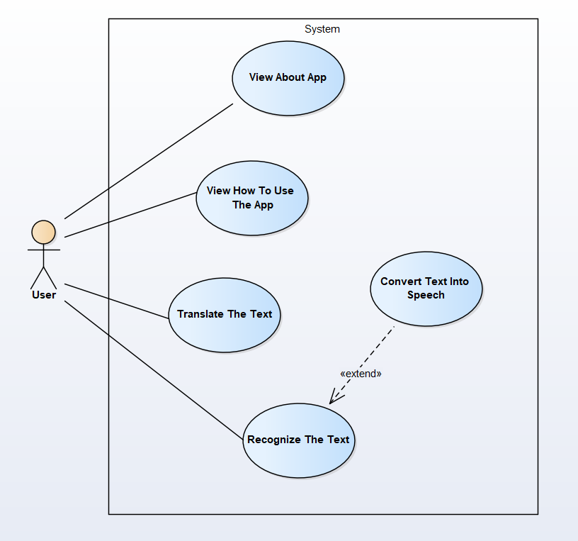

Figure 2. 1: Overall Use Case Diagram

### 2.1.2 Overall Actor

Table 2: Overall Actor

|  |  |
| --- | --- |
| **Actor** | **Description** |
|  | User – a person who interacts with the application |

## 2.2 USE CASE DETAILED AND SEQUENCE DIAGRAM

## 2.2.1 View About App Diagrams

* Use case description

Table 3: Use Case View About App

|  |  |
| --- | --- |
| Use Case ID | UC_VAA |
| Use Case Name | View About App |
| Description | This use case allows users to view information about the app, including its features and the Machine Learning libraries used in the app. |
| Actor | User |
| Pre-Condition(s) |  |
| Post-Condition(s) |  |
| Basic Flow | 1. Actor chooses About App from main screen 2. The system displays tabhost 3. Actor chooses tab “About App” 4. The system displays the information of the app |
| Alternative Flow |  |
| Exception Flow |  |

* **Sequence diagram**

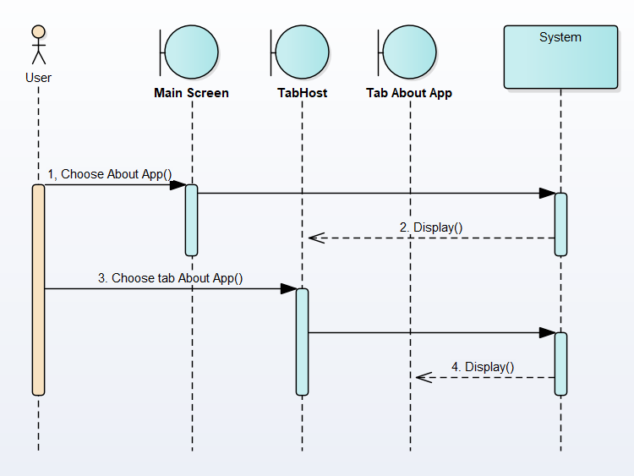

Figure 2. 2: Sequence diagram of About App

**Figure 3. 1 Sequence diagram of Login**

## 2.2.2 View How To Use The App Diagrams

* **Use case description**

Table 4: Use case Log Out

|  |  |
| --- | --- |
| Use Case ID | UC_VHUA |
| Use Case Name | View How To Use The App |
| Description | This use case allows users to view how to use the features of the app |
| Actor | User |
| Pre-Condition(s) |  |
| Post-Condition(s) |  |
| Basic Flow | 1. Actor chooses About App from main screen 2. The system redirects tab “Usage” and displays how to use the features of the app |
| Alternative Flow |  |
| Exception Flow |  |

* **Sequence diagram**

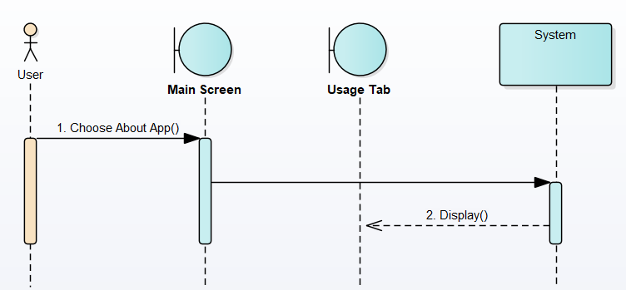

Figure 2. 3: Sequence diagram of View How To Use App

## 2.2.3 Translate Text Diagrams

* **Use Case description**

Table 5: Use case of Register

|  |  |
| --- | --- |
| Use Case ID | UC_TT |
| Use Case Name | Translate The Text |
| Description | This use case allows users to translate between different languages |
| Actor | User |
| Pre-Condition(s) |  |
| Post-Condition(s) |  |
| Basic Flow | 1. Actor chooses “Translate” from main screen 2. The system displays translation screen 3. Actor selects the source language and the target language to translate 4. Actor enters the text and chooses “Translate” button [A1] 5. The system performs language translation and displays the output in the text box. |
| Alternative Flow | [A1] Actor can paste the text from clipboard |
| Exception Flow |  |

* **Sequence diagram**

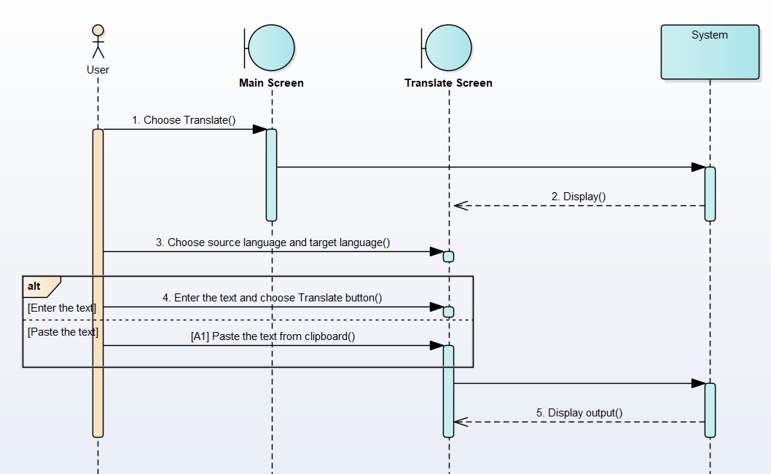

Figure 2. 4: Sequence diagram of Translate Text

## 2.2.4 Recognize the Text Diagrams

* **Use Case description**

Table 6: Use case of Forgot Password

|  |  |
| --- | --- |
| Use Case ID | UC_RT |
| Use Case Name | Recognize The Text |
| Description | This use case allows user to recognize text from images. |
| Actor | User |
| Pre-Condition(s) | The actor has appropriate permissions to access the gallery and camera |
| Post-Condition(s) |  |
| Basic Flow | 1. Actor chooses “Scan” from main screen 2. The system displays scan screen 3. Actor chooses Upload Image 4. The system displays two options 5. Actor chooses upload from “Camera” [A1] 6. The system opens the camera to capture the image 7. Actor takes a picture and chooses “check” mark 8. The system displays the picture on ImageView 9. Actor chooses “Recognize Text” button 10. The system recognizes text from the image and displays it in the textbox |
| Alternative Flow: | [A1] Actor chooses upload from “Gallery”  [A1].1 The system displays list image from local storage  [A1].2 Actor chooses the picture and use case continue to step 8 |
| Exception Flow |  |

* **Sequence diagram**

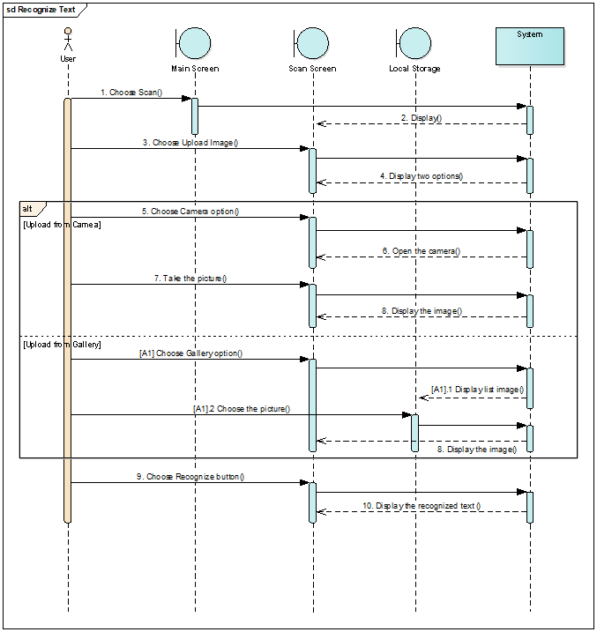

Figure 2. 5: Sequence diagram of Recognize Text from An Image

Figure 3. 2 Sequence diagram of Forgot Password

## 2.2.5Convert Text into Speech Diagrams

* **Use Case description**

Table 7: Use case of Manage Cart

|  |  |
| --- | --- |
| Use Case ID | UC_CTS |
| Use Case Name | Convert Text into Speech |
| Description | This use case allows the actor to convert text into speech. |
| Actor | User |
| Pre-Condition(s) | Actor has been entered the text in textbox |
| Post-Condition(s) |  |
| Basic Flow | 1. Actor chooses “Speech” button from Scan screen [A1] 2. The system reads the text and converts it into speech. |
| Alternative Flow | [A1] Actor chooses “Speech” button from Translate screen |
| Exception Flow |  |

* 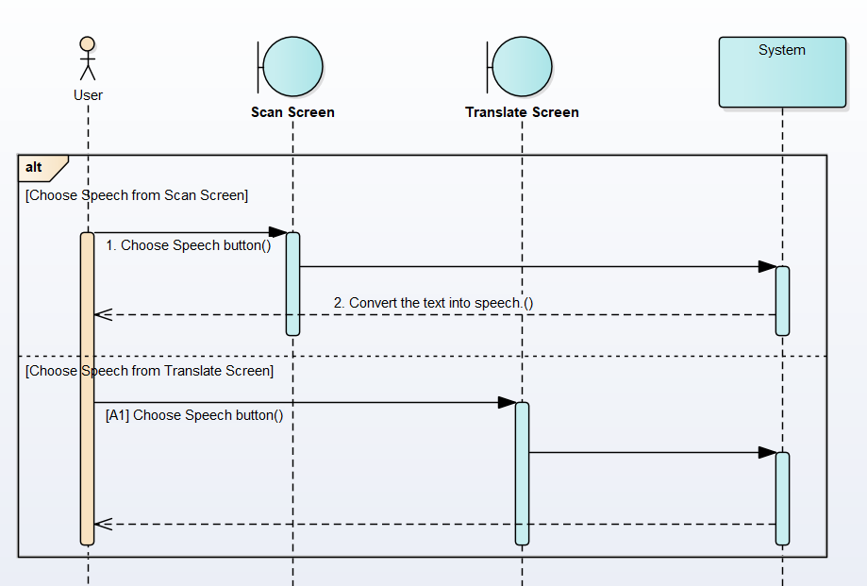 **Sequence diagram**

Figure 2. 6: Sequence diagram of Convert Text into Speech

# CHAPTER 3: USER INTERFACE DESIGN

## 3.1 Introduction Screen

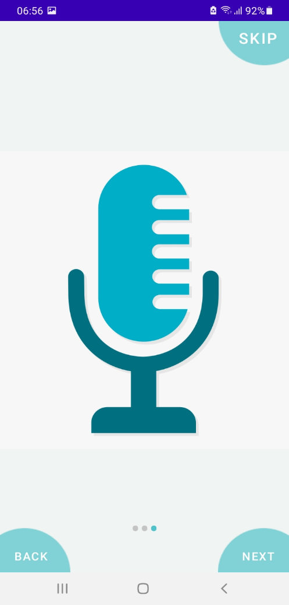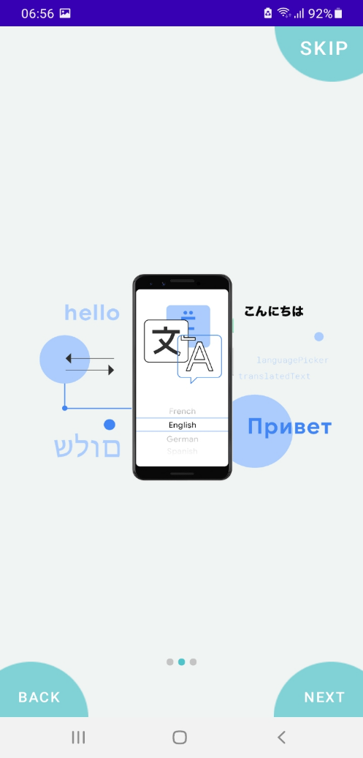

Figure 3. 1: Introduction Screen of App

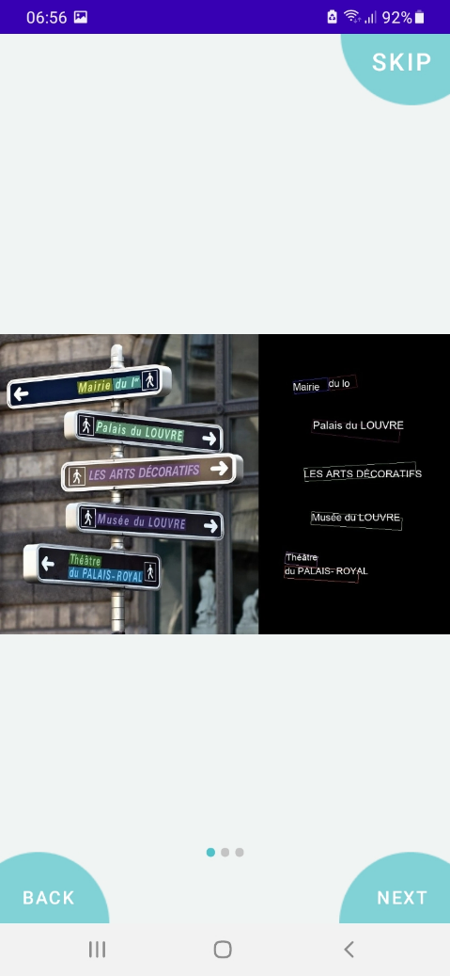

## 3.2 Main App Screen

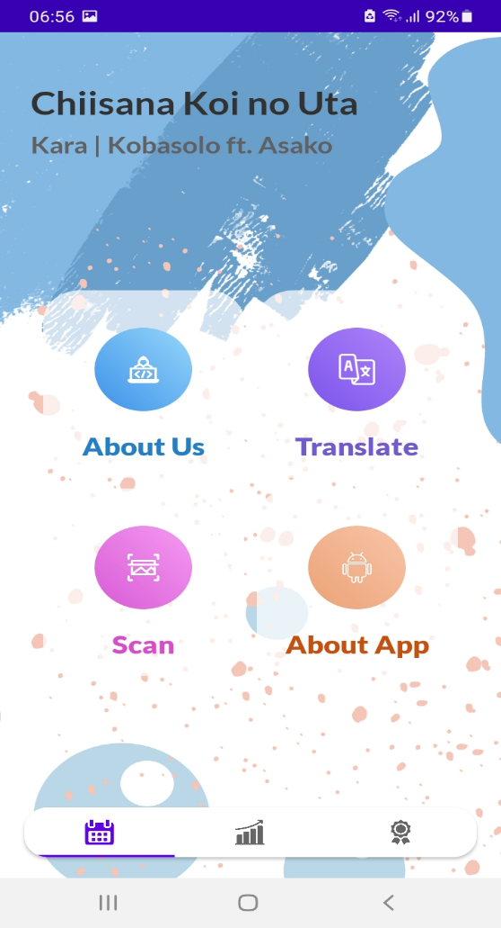

Figure 3. 2: Main App Screen

### 3.2.1 About App Screen

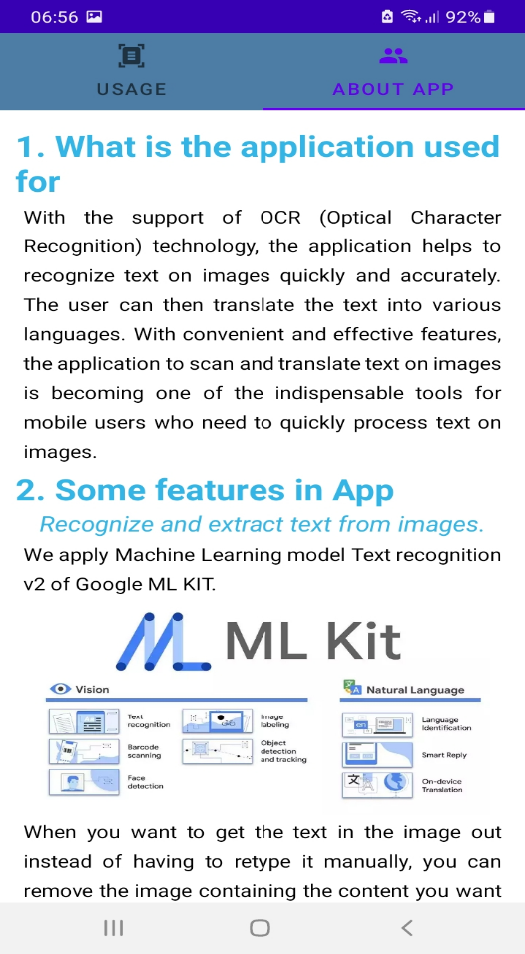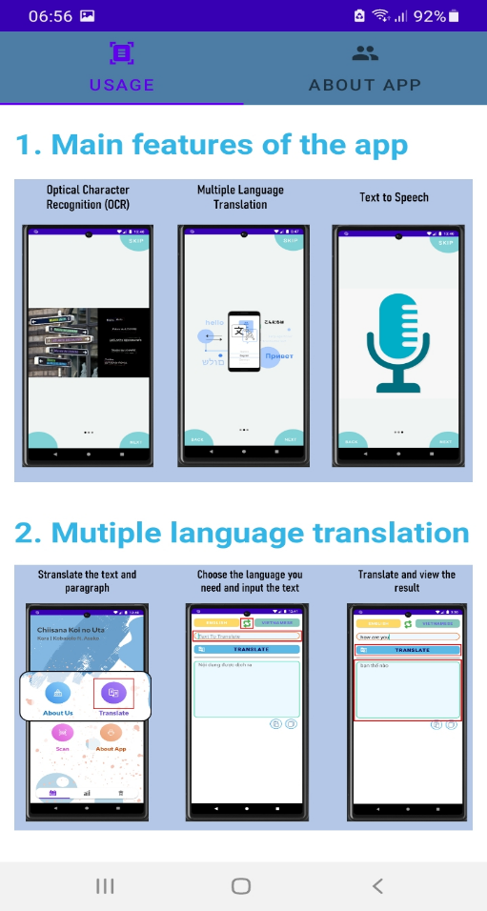

Figure 3. 3: About App Screen

### 3.2.2 About Us Screen

Figure 3. 4: About Us Screen

### 3.2.3 Translate Screen

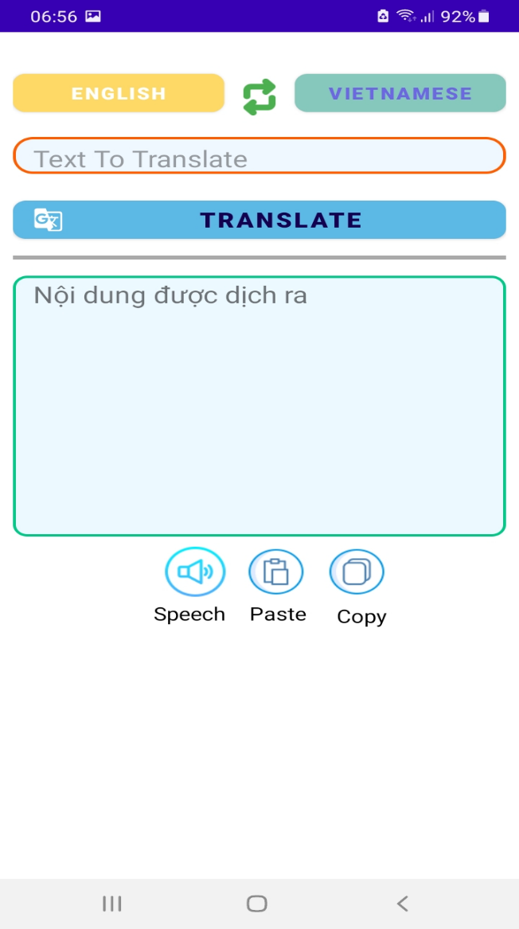

Figure 3. 5: Translate Screen

### 3.2.4 Scan Screen

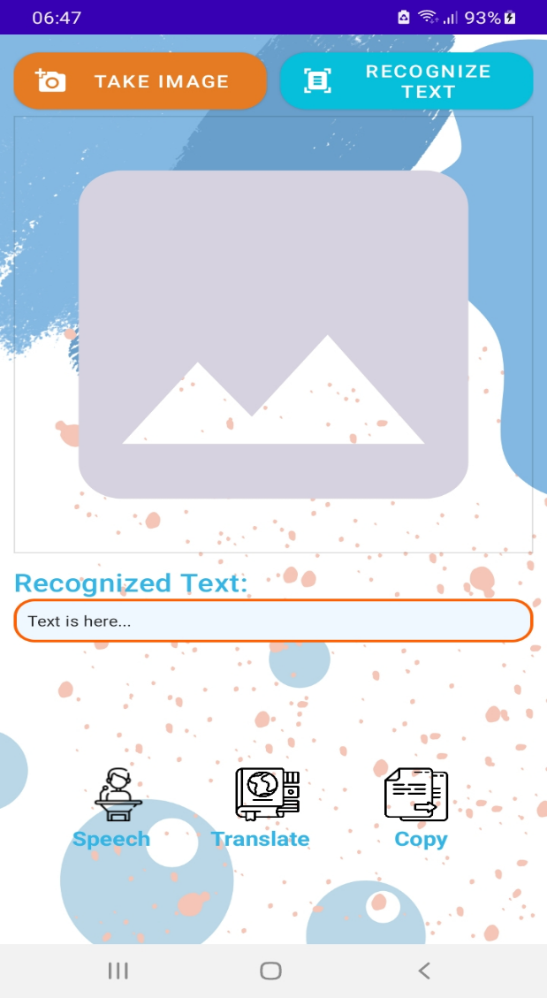

Figure 3. 6: Scan Screen

# CHAPTER 4: CONCLUSION AND DEVELOPMEN

## ACHIEVEMENT

During the implementation process, we encountered numerous challenges and difficulties. Accessing new programming languages and developing mobile applications while applying AI to the app remains a challenge for us due to our lack of experience with AI and time constraints for research. However, thanks to the effort and collaboration of the team members, we overcame these obstacles and achieved the expected results.

After a period of research, topic execution, and program design, our team achieved the desired results. Additionally, we gained some valuable experience:

* Our team has gained a better understanding of the implementation process and how to work collaboratively to manage app design.
* We have also learned about design principles and how to create user-friendly and visually appealing applications.
* We now understand the importance of Machine Learning, specifically, and AI in general. Applying Machine Learning and AI algorithms to our team's app and future app designs is crucial to making the app more flexible and efficient.

## ADVANTAGES AND DISADVANTAGES

### 4.2.1 Advantages

* AI and Machine Learning have been widely developed and supported by many large companies such as AWS and Google KIT, and there are many libraries and APIs available for easy use and application in our project.
* We have the opportunity to access new technology and gain a better understanding of the importance of artificial intelligence when applied to various applications.
* There are many existing interfaces and color schemes designed for easy selection and programming of user-friendly interfaces.

### 4.2.2 Disadvantages

* We are still facing some difficulties in handling AI and Machine Learning-related issues, such as optimizing models and improving accuracy.
* Due to time constraints, we have not been able to fully develop and optimize the user experience of our app.
* We have not yet fully optimized the process of loading models when the app first detects a new language.

## 4.3 DEVELOPMENT

The explosion of artificial intelligence in recent years is completely changing the way we live and work. With the remarkable increase in computing power, data, and deep learning algorithms, AI has become one of the hottest technology trends today. Therefore, in the future, our team will continue to develop this application with better language recognition capabilities using more rigorously trained models. We will also improve the text-to-speech function of the app to enable better pronunciation in different languages. This will help users who want to use the app for traveling, communicating with foreign partners, or learning a new language.

Additionally, our team wants to implement a feedback function from users to help us improve the accuracy of the translation. Furthermore, we plan to research and develop a feature that allows real-time translation through video recording or automatic subtitle translation when users import videos into the app.

# WORKLOAD

Table 8: Workload

|  |  |  |
| --- | --- | --- |
| **Student Name** | **Completion Rate** | **Taskwork** |
| Phan Thành Luân | 100% | PO, UI Designer, Backend, write report |
| Huỳnh Quốc Thoại | 100% | UI Designer, Requirement analysis, Backend, write report |
| Huỳnh Đăng Khoa | 100% | UI Designer, Requirement analysis, Backend, write report |

# REFERENCES

[1] ML Kit, Translation – Link Access: <https://developers.google.com/ml-kit/language/translation>

[2] ML Kit, Translate text with ML Kit on Android – Link Access: <https://developers.google.com/ml-kit/language/translation/android>